Algebra 3-4 Name: ____________________

Chapter 4 Re-Test Block: ________

For problems 1 – 3, graph and label the vertex and axis of symmetry.
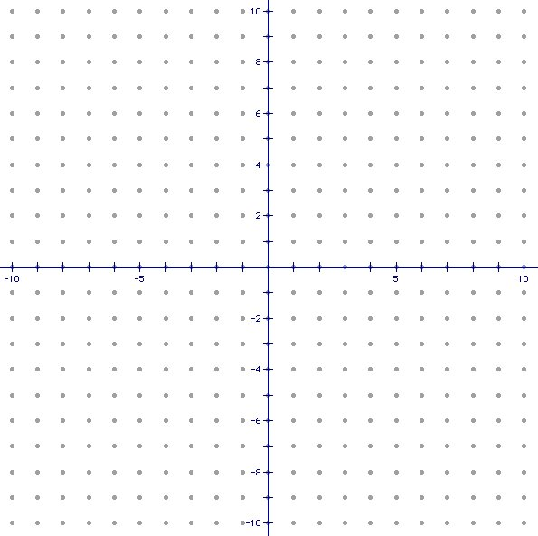
1. y = (x – 2)² – 10

2. y = – 2(x – 2)(x – 4)

3. 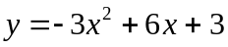

For problems 4 – 5, write the quadratic function in standard form.

4. y = 5(x – 2)² – 10 5. y = – (x + 3)(x – 4)

Standard Form: __________________ Standard Form: __________________

For problems 6 – 7, write the quadratic function in intercept form and then find the zeros of the function.

6. y= x² – 4x – 5

Intercept Form: ________________

Zeros: ________________________

7. . y= x² – 81

Intercept Form: ________________

Zeros: ________________________

For problem 8, choose the correct intercept form of the quadratic function.

8. 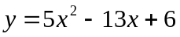

A. y = (5x + 3)(x + 2)

B. y = (5x + 3)(x – 2)
C. y = (5x – 3)(x + 2)

D. y = (5x – 3)(x – 2)

For problems 9 – 10, write the quadratic function in vertex form and identify the vertex.

9. y = – x² + 4x – 1

Vertex Form: ____________________

Vertex: _________________________

10. y = x² – 16x + 2

Vertex Form: ____________________

Vertex: _________________________

For problems 11 – 12, graph the quadratic inequality.
11. y > x² – 2x – 3

12. y ≤ – x² + 6x – 7

For problems 13 – 14, solve the quadratic inequality.

13. 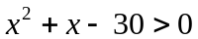

14. 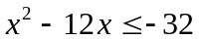

For problem 15, find what is needed.

15. Given below are three solutions students turned in on a test. Are these solutions the same? Explain your reasoning.

Student A: y = 3(x – 3)² Student B: y = 3x² – 18x + 27 Student C: y = 3(x – 3)(x – 3)

